Chapter 17, Solution 21.

Determine the trigonometric Fourier series of the signal in Fig. 17.59.

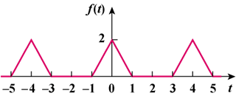

Figure 17.59
For Prob. 17.21.

Solution

This is an even function.

b_{n} = 0, T = 4, ω_{o} = 2π/T = π/2.

f(t) = 2 − 2t, 0 < t < 1
= 0, 1 < t < 2
a_{o} = = 0.5

a_{n} =

= [8/(π²n²)][1 − cos(nπ/2)]

f(t) = $\frac{1}{2}+\sum_{n=1}^{∞}{\frac{8}{n^{2}π^{2}}\left[1-\cos\left(\frac{nπ}{2}\right)\right]\cos\left(\frac{nπt}{2}\right)}$

